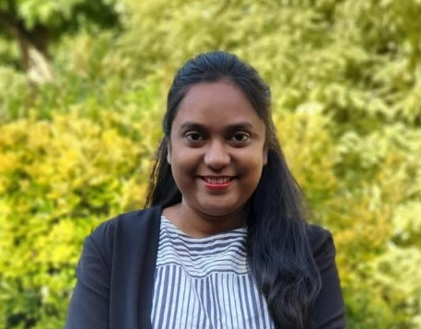Name : Venkata Sudha Manjusha

Family name : Vanarla

Date of Birth : 12th June 1991

Height : 5 feet 2 inches

Weight : 58 kg

Education : Masters in Mechanical engineering from RMIT University, Melbourne, Bachelors in Mechanical engineering from Sri Venkateswara niversity, Tirupati.

Profession : Worked as production engineer in Melbourne. Currently relocated to India and looking for job.

Religion : Hindu

Caste : Rajaka/ Madivala/ Vannar

Native/ Location : Tirupati, Andhra Pradesh.

Place of birth : Ongole, Andhra Pradesh.

Time of birth : 6:15 AM

Hobbies : Movies, music

# Family Background:

Father : Nagasivudu, Retired Executive Director, APSRTC

Mother : Nagamani, homemaker

Siblings : 2 elder sisters, both married and settled with two children each. No brothers.

Well educated bride with good career prospectus, willing to relocate. Seeking profiles of family-oriented grooms. Please contact below

Phone number : +91-7382843999